SQL Server 2017 Standard Build

Enterprise 64-bit

Step by step instructions for standard SQL 2017 setup

Prepared by:
HSSBC Database Services
April, 2018

Table of Contents

SQL Server 2017 Standard Build 1
1 Document Version 3
2 Prerequisites for installation 4
2.1 Disk drives and folders 4
2.2 Storage type and LUN configuration 4
2.3 Software Requirements 5
2.4 Adjust local security policy rights for SQL service account 6
2.5 Set user as local admin on PHSABC domain 6
3 SQL Server 2017 Setup 7
3.1 Locate and run Setup.exe 7
3.1.1 Product Key 8
3.1.2 License Terms 9
3.2 Feature Selection 11
Instance Configuration 12
3.3 Server Configuration 13
3.3.1 Service Accounts Tab 13
3.4 Database Engine Configuration 15
3.4.1 Account Provisioning 15
3.4.2 Data Directories 16
3.5 TempDB Optimization 16
3.5.1 FILESTREAM 17
3.6 Analysis Services Configuration 19
3.6.1 Account Provisioning 19
3.6.2 Data Directories 20
3.7 Microsoft R and Python features 22
3.8 Feature Configuration Rules 24
3.9 Ready to Install 25
Complete 26
3.10 Install SQL Server Management Tools 26
4 SQL Server 2017 Configuration 30
4.1 TCP/IP Port Setting 30
4.2 Memory Allocation 30
4.3 Database Settings 31
4.4 Model database optimization 31
4.5 Set up Standard Maintenance 32
4.6 uCMDB User 32
4.7 Restart SQL Services 32
4.8 Add Server to Inventory 33
4.9 Create Integration Services Catalog 34
4.9.1 Right click on the Integration Catalogs node and select Create Catalog. 34

Document Version
Date | Changed By | Version | Description Of Changes
04/06/2018 | James Zhang | 1.0 | Initial Version

Prerequisites for installation

Disk drives and folders

Each SQL Server must have the following disks dedicated to SQL Server service, recommended disk sizes are based on the total disk space required for data files:
- H (Data): 100%
- I (Log): 25% of Data
- J (TempDB): 25% of Data
- K (Backup): 150% of Data
In order to separate SQL related files from other files that might accidentally be saved on above disk drives, the folders below must be created prior to begin SQL setup:
- H:\SQL_Data
- I:\SQL_Log
- J:\SQL_TempDB
- K:\SQL_Backup
In case we are planning to install a second instance the next four disk drive will be:
- L (Data): 100%
- M (Log): 25% of Data
- N (TempDB): 25% of Data
- O (Backup): 150% of Data

Storage type and LUN configuration
Here is an outline of the storage type and LUN configuration for different disk drives; the following items should be already in place when the Windows server is built, and is only for the reference:
- 5 disks in total, C:/H:/I:/J:/K:
- Disks are grouped into 3 sets for performance and redundancy. C:/H:, I:/J:, and K:. i.e. 3 data stores to be used for each SQL server.
- I:/J: should be on a higher performance data store (i.e. RAID1, or faster disk group)
- Data stores of C:/H: and K: should be separated on different disk sets for redundancy. (e.g. different SAN, or different disk group, or different pool…etc.).

Software Requirements
- A minimum of .NET 4.6.1 is required. The SQL Server 2017 setup will install the necessary files before the actual installation.
- SQL Server setup support files and the native client will be installed first.
- Client versions of Windows 10 or 8.1 and Windows Server 2017 or Windows Server 2012 R2 RTM are needed for SQL Server 2017. Windows Server Essentials and Foundation Editions are also supported. However, the SQL Server setup requires a GUI and will not work on Core editions.
- If you decide to install all the components, you will need hard disk space of 8030 MB.
- Storage type will either need to be local, shared, storage space (S2D). SMB is also supported with certain limitations.
- SQL Server has limitations when installing on a domain controller. Failover clustering is not supported on a DC.
- SQL Server Core engine is 64-bit only and does not support the 32-bit editions of Windows 8 or Windows 10. Barring a few 32-bit components like Client Tools, Data Quality Client, and others, all other parts will need native 64-bit support.

Adjust local security policy rights for SQL service account
For any Windows operating system, on the Start menu, click Run.
- Type secpol.msc and then click OK. If the User Access Control dialog box appears, click Continue.
- In the Local Security Policy tool, expand Security Settings, expand Local Policies, and then click User Rights Assignment.
- In the results pane, double-click Generate security audits.
- On the Local Security Setting tab, click Add User or Group.
- In the Select Users, Computers, or Groups dialog box, either type the name of the SQL service account, such as domain1\user1 and then click OK, or click Advanced and search for the account.
- Click OK.
- Close the Security Policy tool.

Note:
This setting takes effect when SQL Server is restarted.

Set user as local admin on PHSABC domain
When you install SQL Server, the system grants Log On As A Service right to the service account. However, on PHSABC domain, Active Directory will come along 90 minutes later and take away this right and cause SQL Server to fail when it starts up again. Go to Run…, type lusrmgr.msc, click Groups, double click Administrators, and add the service account.

SQL Server 2017 Setup

Locate and run Setup.exe
While you are signed in the server as your SA account which must be a member of SR HSSBC SQL Admin (CrossHA) group, run SQL 2017 setup program.

Once SQL Server Installation Center window pops up, click on Installation link on the left, and select New SQL Server stand-alone… as shown below:

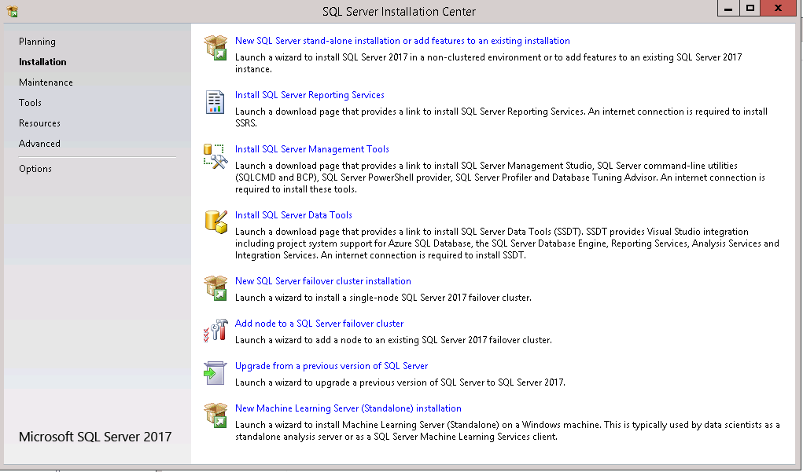

Product Key
Leave the default value for product key:
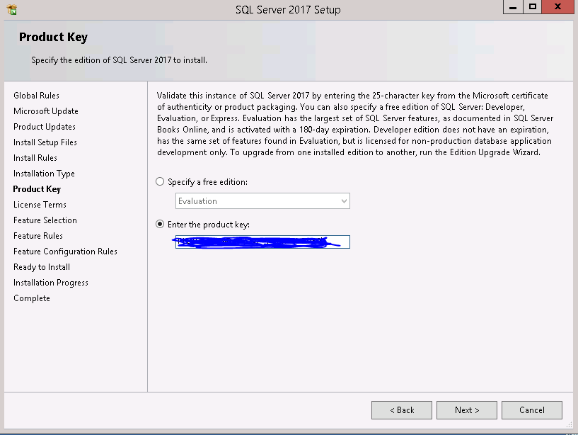

Press Next button.

License Terms
Check I accept the license terms as shown below:
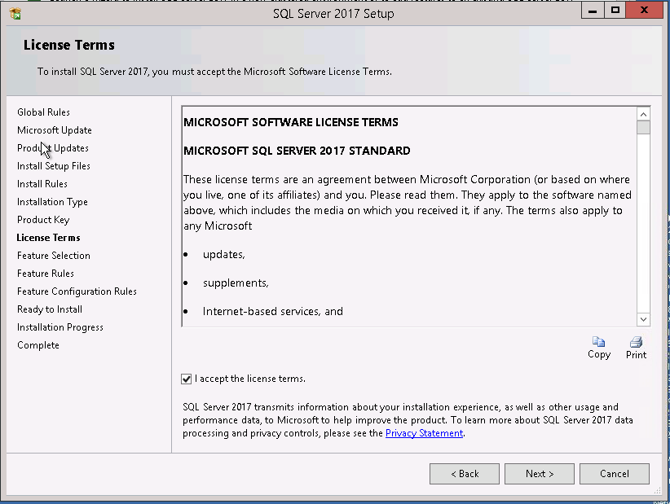
Press Next button.
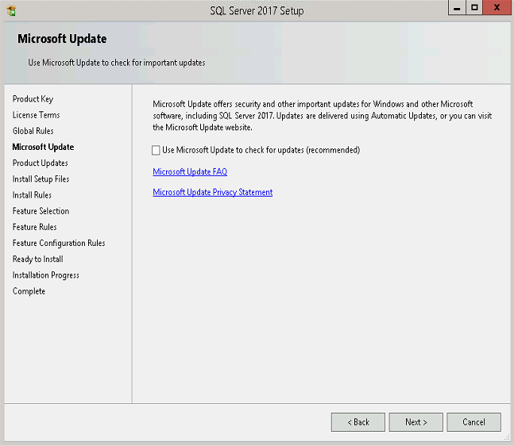

Press Next

Feature Selection
Select only the items required for this install, leave the default settings for Shared feature instance root directory text boxes:
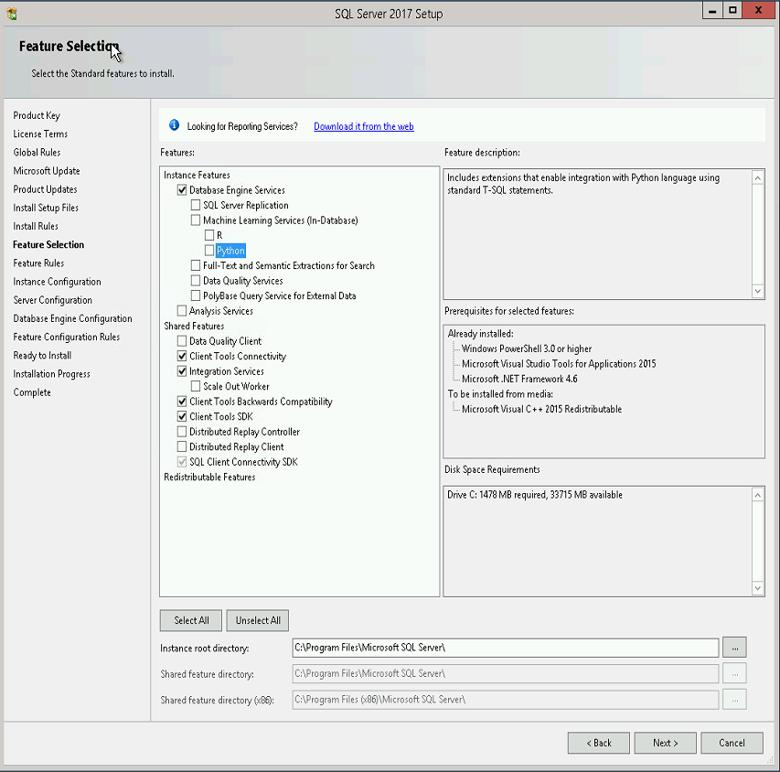
Press Next button.

Instance Configuration
Leave all the default settings and press Next button, in case a default SQL Server instance already exists, select Named instance option, and enter the instance name in the related text box:

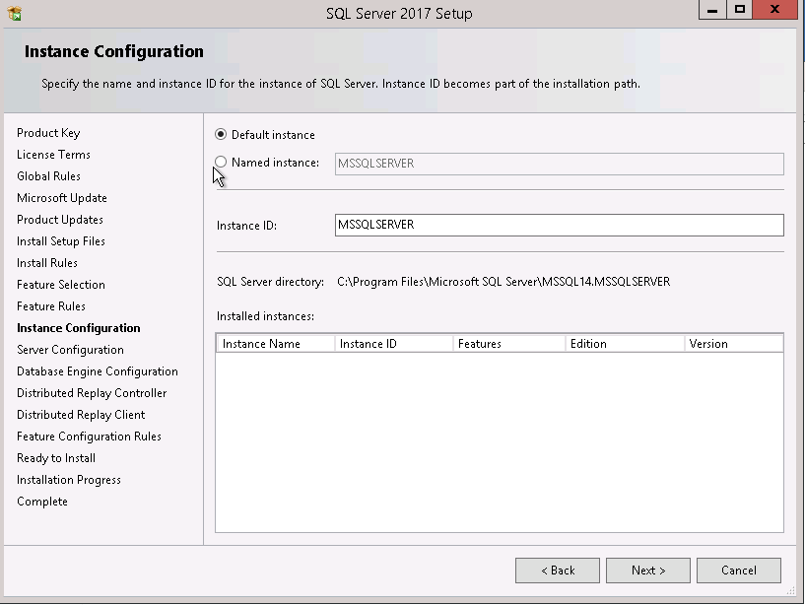

Press Next button.

Server Configuration
This section contains two tabs:

Service Accounts Tab
Before starting this section, have a domain service account created by a domain administrator for the SQL Server, and save its credentials in Secret Server. Follow the steps below:
- Change Startup Type for SQL Server Agent from “Manual” to “Automatic”
- Press Use the same account for all SQL Server services button:
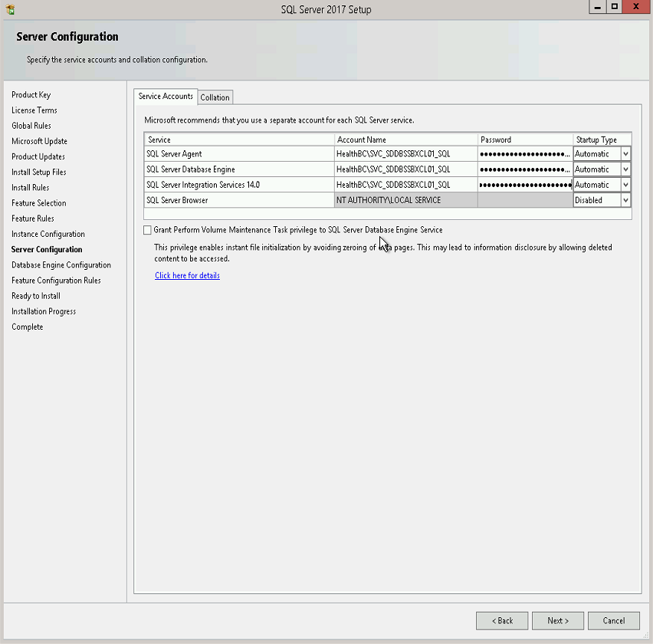

Collation Tab
Keep default settings on this tab unless the business requirements mandates a customized collation for all databases across SQL Server:
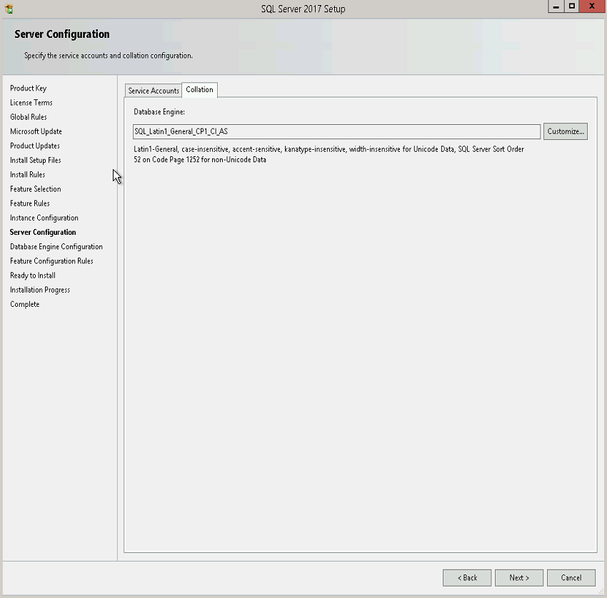

Press Next button.

Database Engine Configuration
This section contains three tabs:

Account Provisioning
Follow the steps below:
- Select Windows authentication mode
- Press Add… button marked below, and Enter one of the domain local groups below depending on HA the SQL Server belongs to:
- HEALTHBC\Database Services Group (HSSBC) - (SA)
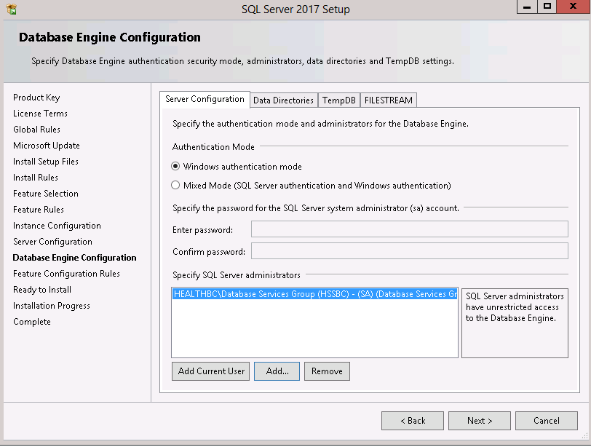

Data Directories
Make sure the following folders exist in server’s H, I, J, and K drive, and enter them in Data Directories tab accordingly:
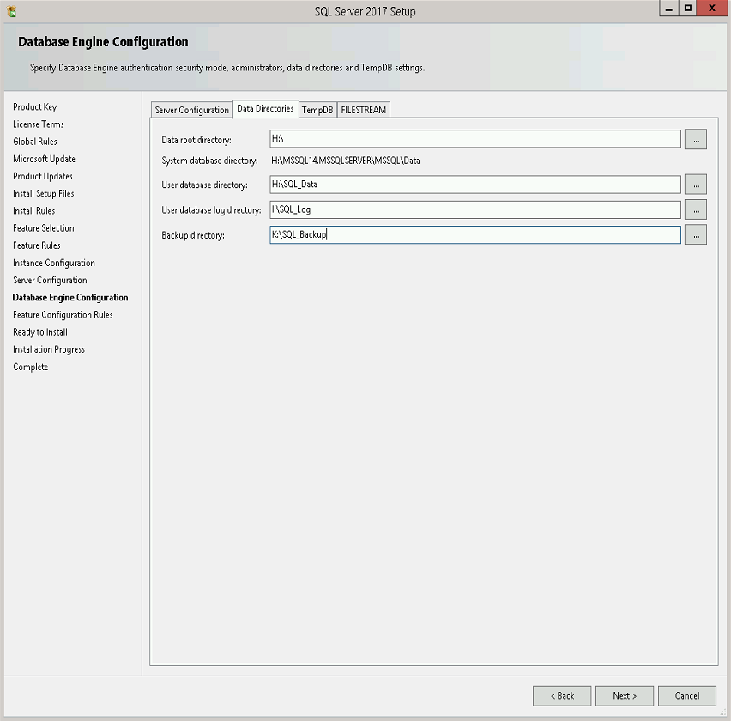

TempDB Optimization

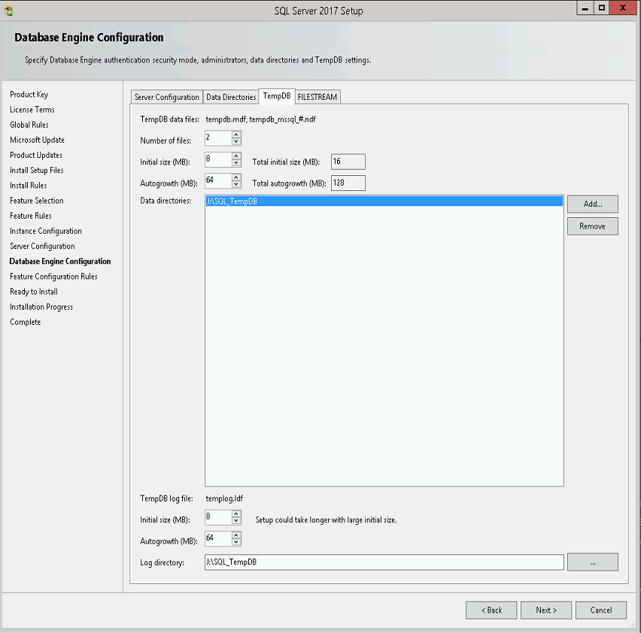
Press Next Tab, “FILESTREAM”.

FILESTREAM
Keep the default settings, with FILESTREAM disabled
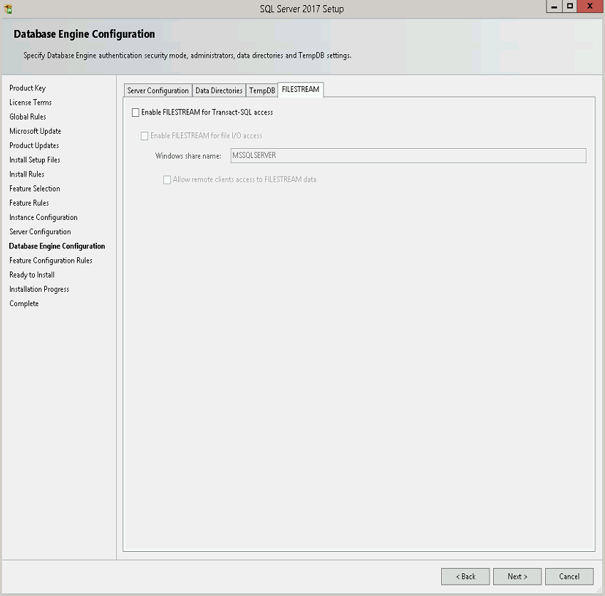
Press Next button.

Analysis Services Configuration
You will see the following configuration if Analysis services feature is selected

This section contains two tabs:

Account Provisioning
Server mode is a server property that determines which storage and memory architecture is used for that instance.
Confirm with business as to which mode, “Multidimensional and Data Mining” or “Tabular” else select the simplified modeling mode, “Tabular”.

Press Add… button marked below, and Enter one of the domain local groups below depending on HA the SQL Server belongs to:
HEALTHBC\Database Services Group (HSSBC) – (SA)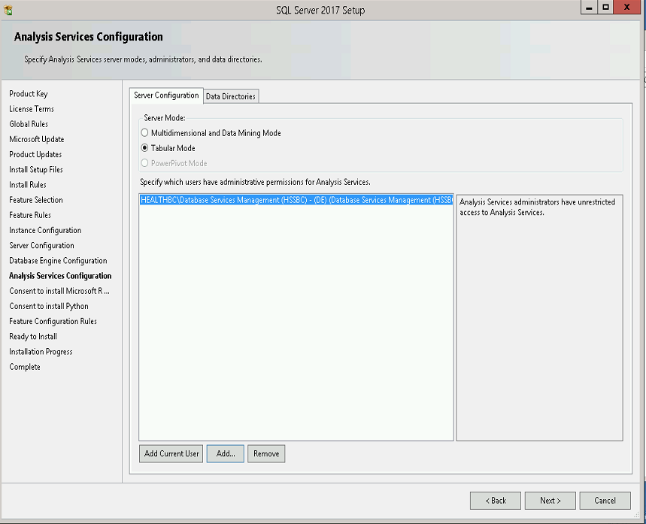

Data Directories
Make sure the following folders exist in server’s H, I, J, and K drive, and enter them in Data Directories tab accordingly:
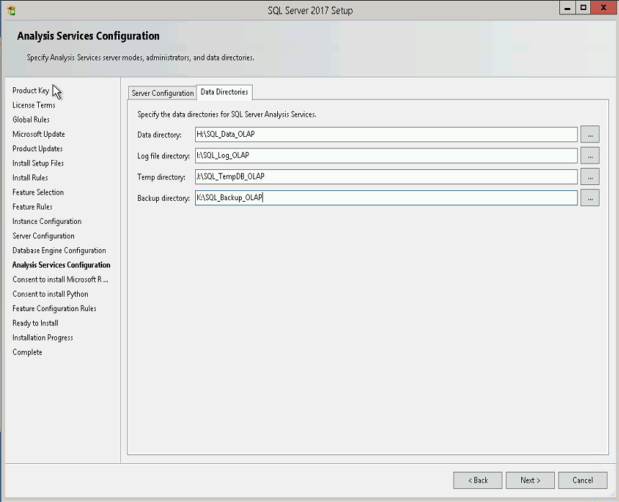

Press Next button.

Microsoft R and Python features

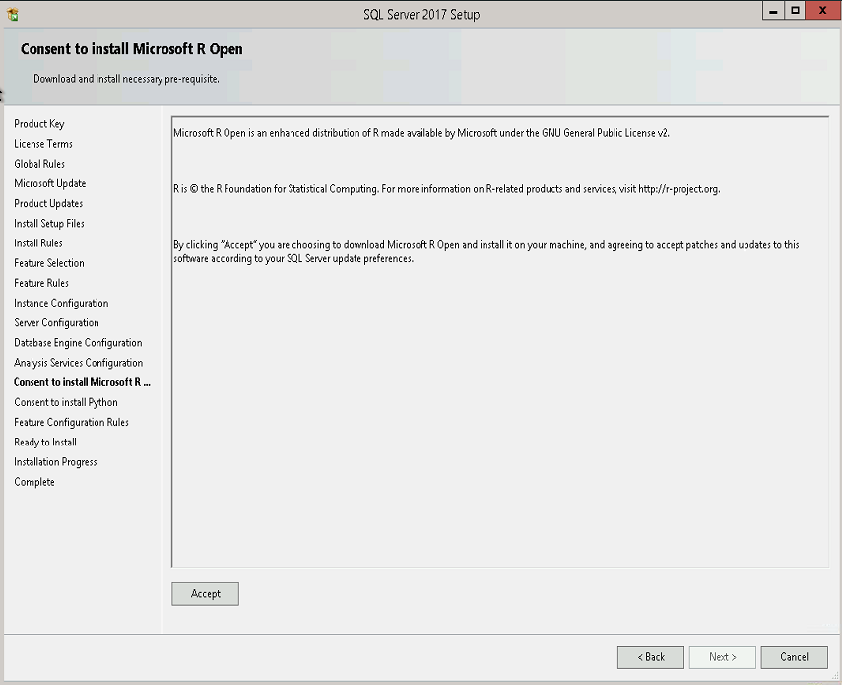
Click Accept, then click Next.
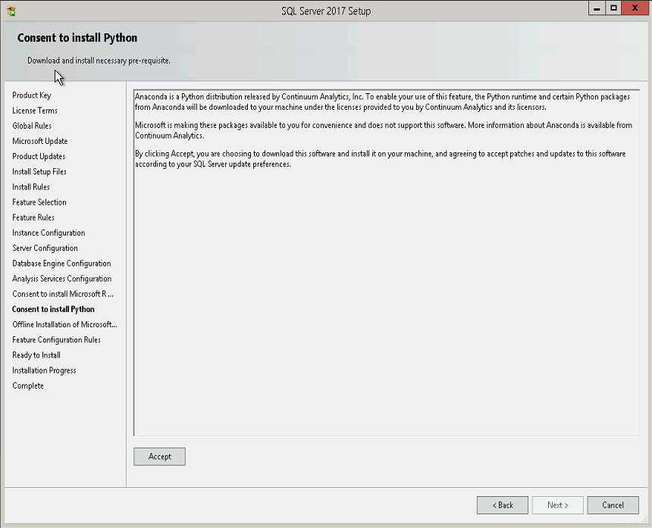

Click Accept, then click Next.
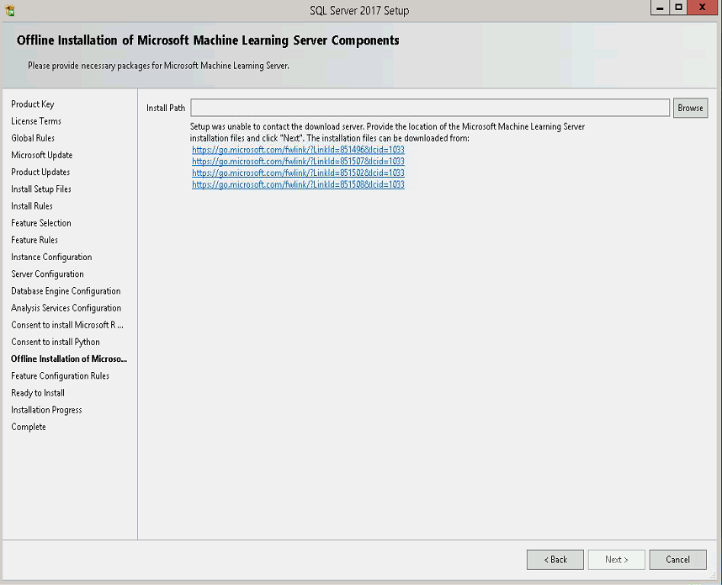
Specify a path to install the Machine Learning Server Components.

Feature Configuration Rules
Wait until Configuration Rules is completed, press Show details button and check the rules, if they are all passed as follows:

Ready to Install
Press Install button:
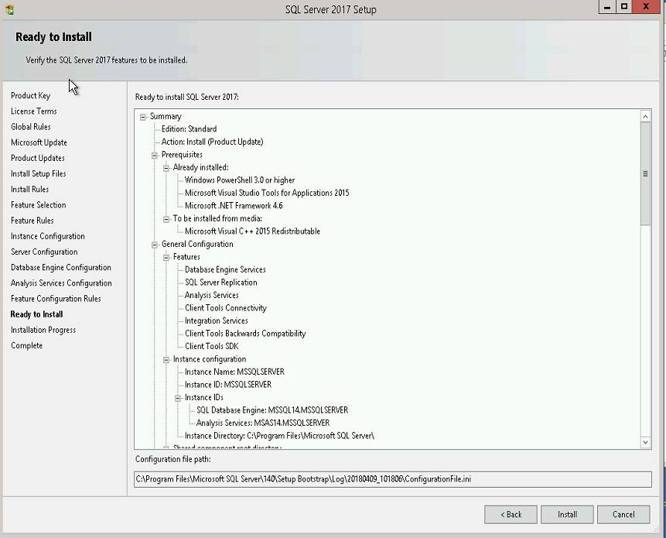

Complete
Press Close button:
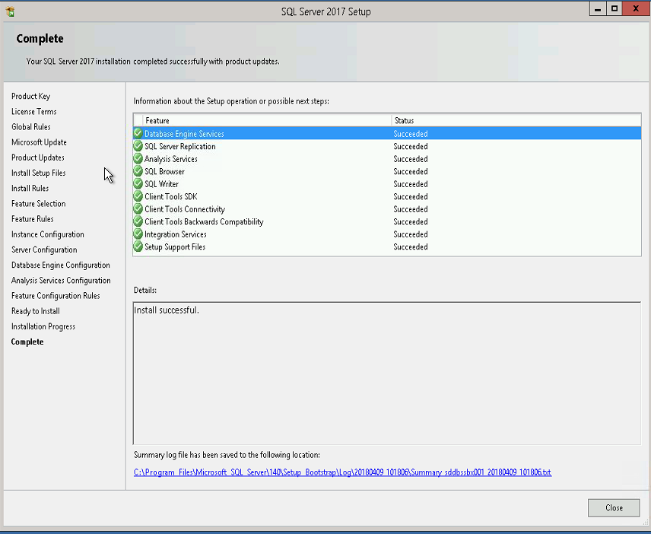

Install SQL Server Management Tools
Once SQL Server Installation Center window pops up, click on Installation link on the left, and select Install SQL Server Management Tool as shown below to download the installation file or go Database services TeamSites, for SSMS-Setup-ENU.exe.

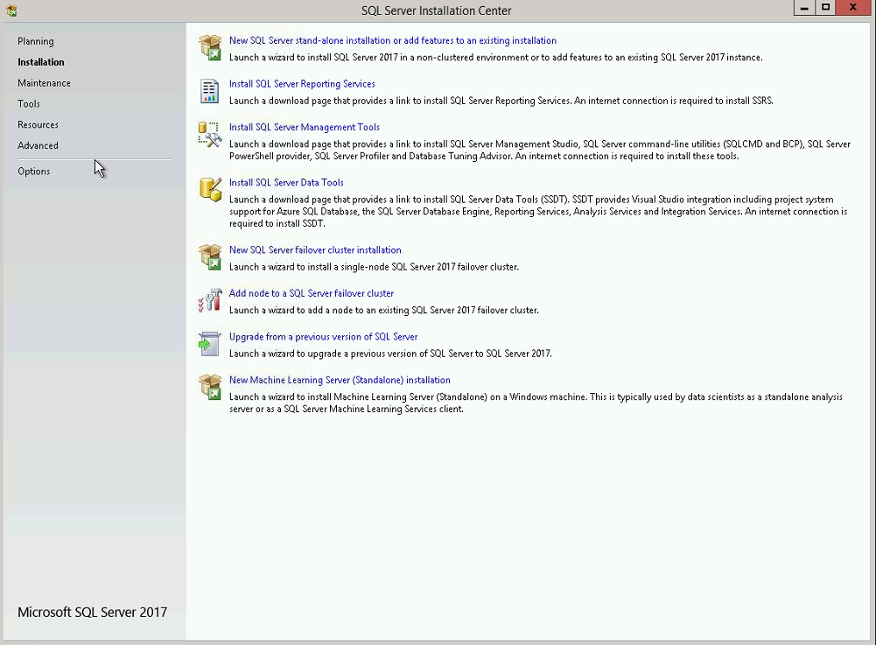

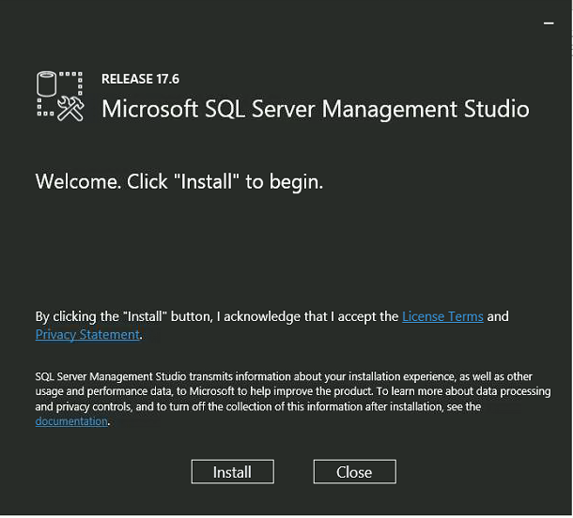
Click Install.
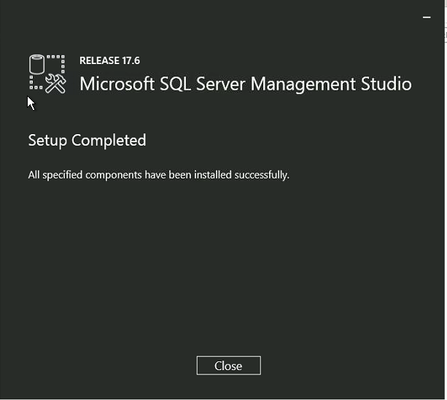
Click Close when setup completed.

SQL Server 2017 Configuration

TCP/IP Port Setting
Leave the default instance port as 1433. For additional instances use 1533, 1633, etc.

Memory Allocation
Open Server Properties window, and set the Maximum server memory to lower than maximum available physical memory as per table below:
Physical RAM | Max Server Memory
8GB | 6000
12GB | 10000
16GB | 14000
24GB | 21500
32GB | 29000
64GB | 60000

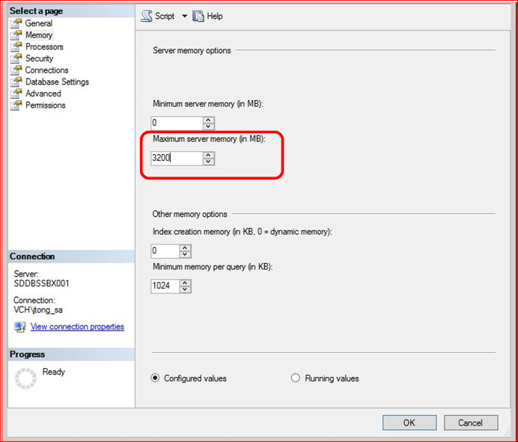

Database Settings
Check Compress backup to create compressed backups by default.
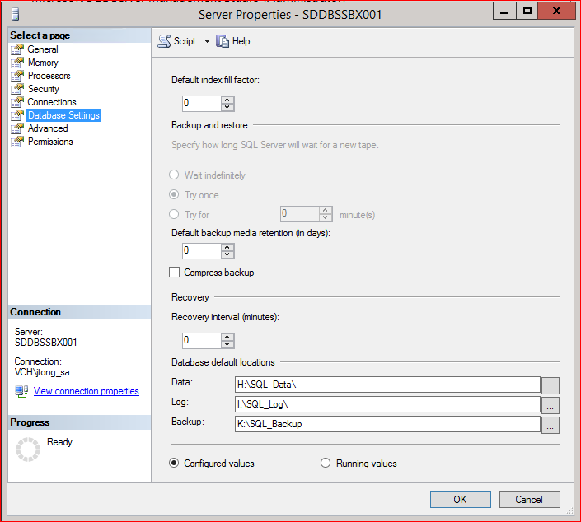

Model database optimization
New databases are created by default with the same settings as model database. Set optimal values for autogrow settings:
USE [master]
GO
ALTER DATABASE [model] MODIFY FILE ( NAME = N'modeldev', SIZE = 10240KB , FILEGROWTH = 102400KB )
GO
ALTER DATABASE [model] MODIFY FILE ( NAME = N'modellog', SIZE = 10240KB , FILEGROWTH = 51200KB )
GO

Set up Standard Maintenance
Open and execute the two scripts below from Shared Documents on Database Services team site (Maintenance Version 4) in order to create required stored procedures and jobs for standard Maintenance:
- Script1: 01_setup_database_mail_sql_agent_alert.sql
- Script2: 02_db_maint_script_package.sql

uCMDB User
uCMDB needs a login to be able to make an inventory of databases. Add the following as a login on the SQL server. It doesn’t need to be given any rights (the default Public is enough to query sysdatabases):
healthbc\SVC_HP_uCMDB

Restart SQL Services
Restart SQL Server and SQL Agent services.

Add Server to Inventory
Register Central Management Server if it has not been done already. Please note that you might not be able to do it from the server you are installing because firewall will not allow it. You can use SSMS in seth to do it.

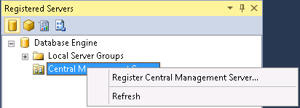

Provide server name: SPMGMTDB001\CMSINST,1433
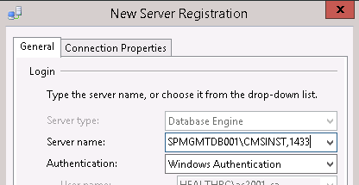

Select the CMDB folder
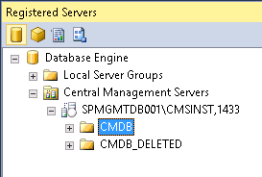

Right-click on the selected folder and select New Server Registration… as follows:
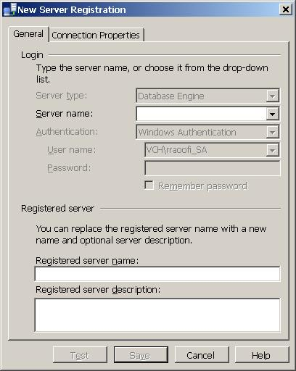
Enter the server name and in the description field put information about the database owner and the application.

Create Integration Services Catalog

Skip this step if Integration Services feature is not installed

Right click on the Integration Catalogs node and select Create Catalog.
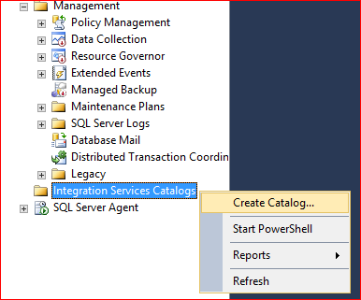

Make sure CLR Integration is not checked.
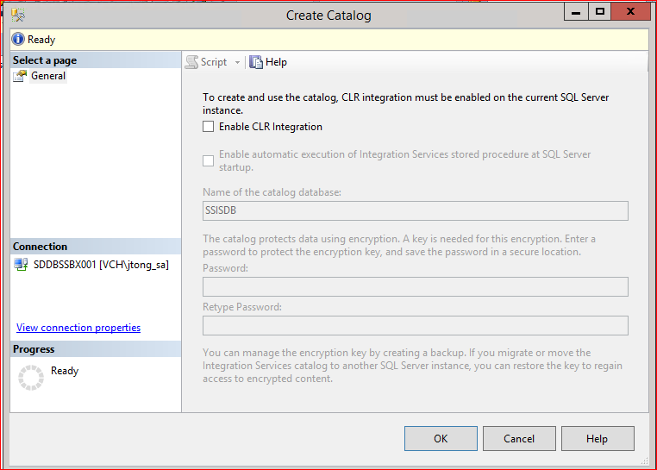
Click OK.

